|  |  |
| --- | --- |
| EGC_Black | Student Name \_\_\_\_\_\_\_\_\_\_\_\_\_\_\_\_\_\_\_\_\_\_\_    **Eastern Goldfields College**  Mathematics U1 2017  Assignment – Calculator Free1 |
|  | **Time allowed: 20 minutes** Total Marks: 16 marks |

***Answer all of the following questions. Show all working to obtain full marks.***

Question 1 (9 marks)

(a) At a certain time of day, the shadow of a 2 m tall post is 4.6 m long. Determine, at the same time of day, the length of the shadow of a tree that is 5 m tall. (3 marks)

(b) The two triangles shown below are similar. Determine the lengths  and . (3 marks)

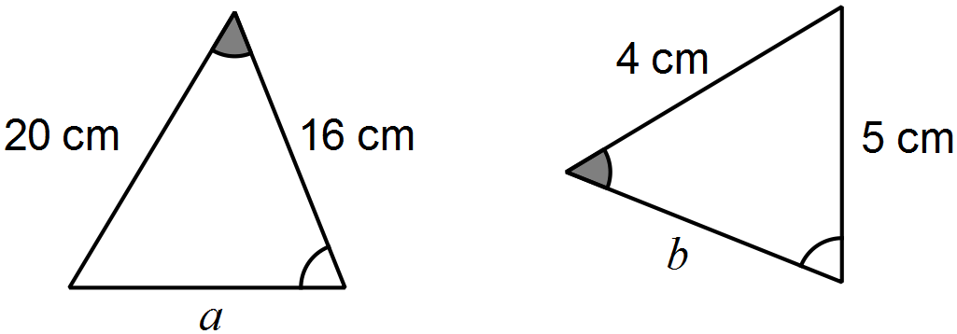

(c) An image, with one side that is 13 cm long, is enlarged so that the same side now measures 39 cm. If the original area of the image was 200 cm2, determine the area of the enlargement. (3 marks)

Question 2 (7 marks)

A system of one-way and two-way paths connects three locations A, B and C. There may be more than one path between any two locations. The table below shows the number of ways to travel between these locations using a single path.

|  |  |  |  |  |
| --- | --- | --- | --- | --- |
|  |  | To | | |
|  |  | A | B | C |
| From | A | 0 | 1 | 1 |
| B | 0 | 0 | 2 |
| C | 2 | 2 | 0 |

(a) Is the path between A and B one-way or two-way? Justify your answer. (1 mark)

(b) Complete the network diagram below to show the information in the table. (2 marks)

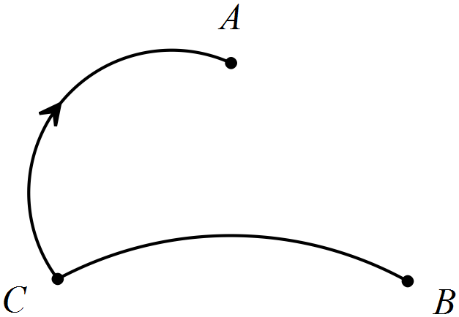

(c) Arrange the information from the table in a matrix  and determine the matrix . (3 marks)

|  |  |
| --- | --- |
| EGC_Black | Student Name \_\_\_\_\_\_\_\_\_\_\_\_\_\_\_\_\_\_\_\_\_\_\_    **Eastern Goldfields College**  Mathematics U1 2017  Test 2 – Calculator Assumed1 |
|  | **Time allowed: 20 minutes** Total Marks: 16 marks |

**Calculator only permitted for this section, no notes.**

***Answer all of the following questions. Show all working to obtain full marks.***

Question 1 (8 marks)

(a) Over a six-year period, the average rate of inflation was 2.9% pa.

(i) At the start and end of this six year period, the salary of a nurse was $64 540 and $76 445 respectively. Comment, with justification, on how the nurses salary increased over the six years compared to the rate of inflation. (2 marks)

(ii) If the price of milk increased at this rate of inflation over the six years to $2.20, calculate the price of milk at the start of the six year period. (2 marks)

(b) A financial institute has two different types of loan for businesses that borrow amounts up to $75 000. Loan type A charges simple interest on the principal borrowed at a rate of 7.49% each year whilst the loan type B charges 6.79% pa interest compounded monthly.

A business needs to borrow $55 000 to purchase some new equipment. The business will be able to repay the loan and interest in full after 30 months.

Which of the two loans will minimise the amount of interest payable by the business?

Justify your answer. (4 marks)

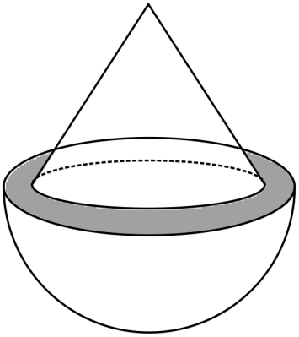Question 2 (9 marks)

A solid cone of radius 12 cm and height 16 cm is placed   
symmetrically atop a solid hemisphere of radius 14 cm   
to form the composite solid shown right.

(a) Use Pythagoras' Theorem to calculate the slant height of the cone. (1 mark)

(b) Determine the area of the grey shaded ring, between the cone and the hemisphere, as shown in the diagram above. (2 marks)

(c) Determine the surface area of the composite solid. (3 marks)

(d) Calculate the volume of the composite solid. (3 marks)